PRACTICAL
Artificial
.
INTELLIGENCE

(A.I)

SHEKHAR SUMAN

CERTIFICATE

Class: T.Y.B.Sc.I.T. |  | Year: 2025 - 2026
This is to certify that work entered in this Journal is the work of
Shri / Kumari: SHEKHAR SUMAN .
of T.Y.B.Sc.I.T division Roll No. 47 .
Uni. Exam No. . has satisfactorily completed the
Required number of practical and worked for the 5th Semester
Of the year 2025 - 2026 in the college laboratory as laid down
By the university.

Head of the | External | Internal Examiner
Department | Examiner | Subject teacher

Date:

NAME: SHEKHAR SUMAN |  | INDEX
CLASS: T.Y.B.Sc.I.T. | ROLL No: 47 | INDEX
SUBJECT: ARITIFICIAL INTELLIGENCE PRACTICAL |  | INDEX
COLLEGE: ST. ROCK’S DEGREE COLLEGE |  | INDEX

PR No: | TITLE | DATE | SIGN

PRACTICAL – 2B
AIM: - Write a program to solve tower of Hanoi problem.
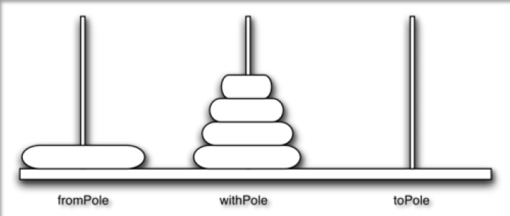

CODE

print("Name: Shekhar Suman")
print("Roll No: 47\n")

def moveTower(height, fromPole, toPole, withPole):
if height >= 1:
moveTower(height - 1, fromPole, withPole, toPole)
moveDisk(fromPole, toPole)
moveTower(height - 1, withPole, toPole, fromPole)

def moveDisk(fp, tp):
print("moving disk from", fp, "to", tp)

moveTower(3, "A", "B", "C")

output
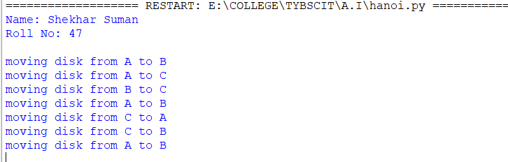
PRACTICAL – 3A
AIM: - Write a program to implement Alpha beta search.
tree = [[[5, 1, 2], [8, -8, -9]], [[9, 4, 5], [-3, 4, 3]]]
root = 0
pruned = 0

def children(branch, depth, alpha, beta):
global tree, root, pruned
i = 0
for child in branch:
if isinstance(child, list):
nalpha, nbeta = children(child, depth + 1, alpha, beta)
if depth % 2 == 1:
beta = min(beta, nalpha)
else:
alpha = max(alpha, nbeta)
branch[i] = alpha if depth % 2 == 0 else beta
else:
if depth % 2 == 0 and alpha < child:
alpha = child
if depth % 2 == 1 and beta > child:
beta = child
if alpha >= beta:
pruned += 1
break
i += 1

if depth == root:
tree = alpha if root == 0 else beta
return (alpha, beta)

def alphabeta(in_tree=None, start=root, upper=-15, lower=15):
global tree, pruned, root
if in_tree is not None:
tree = in_tree
alpha, beta = children(tree, start, upper, lower)

if __name__ == "__main__":
print("Name: Shekhar Suman")
print("Roll No: 47")
print("(alpha, beta):", alpha, beta)
print("Result:", tree)
print("Times pruned:", pruned)
return (alpha, beta, tree, pruned)

if __name__ == "__main__":
alphabeta()

output
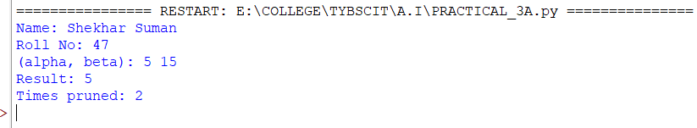

PRACTICAL – 7A
AIM: - Write a program to implement Alpha beta search.
import random

suits = ["Hearts", "Diamonds", "Clubs", "Spades"]
royals = ["J", "Q", "K", "A"]

cardfaces = [str(i) for i in range(2, 11)] + royals

deck = []
for suit in suits:
for face in cardfaces:
deck.append(face + " of " + suit)

random.shuffle(deck)

print("Name: Shekhar Suman")
print("Roll No: 47\n")

for card in deck:
print(card)

import itertools, random

deck = list(itertools.product(
['2','3','4','5','6','7','8','9','10','J','Q','K','A'],
['Spade','Heart','Diamond','Club']
))

random.shuffle(deck)

print("\nYou got:")
for i in range(5):
print(deck[i][0], "of", deck[i][1])

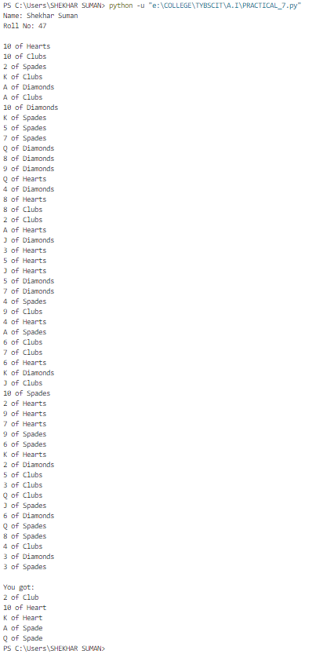
output

